- Lights plugin.
Prompt: “Turn on light 2”
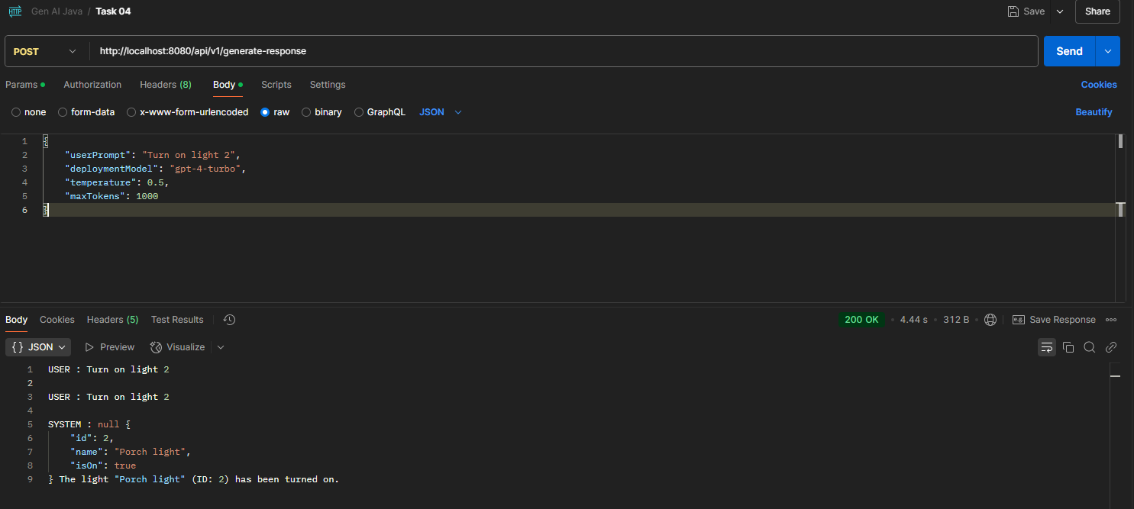
Lights interactive responses for several continuous prompts.
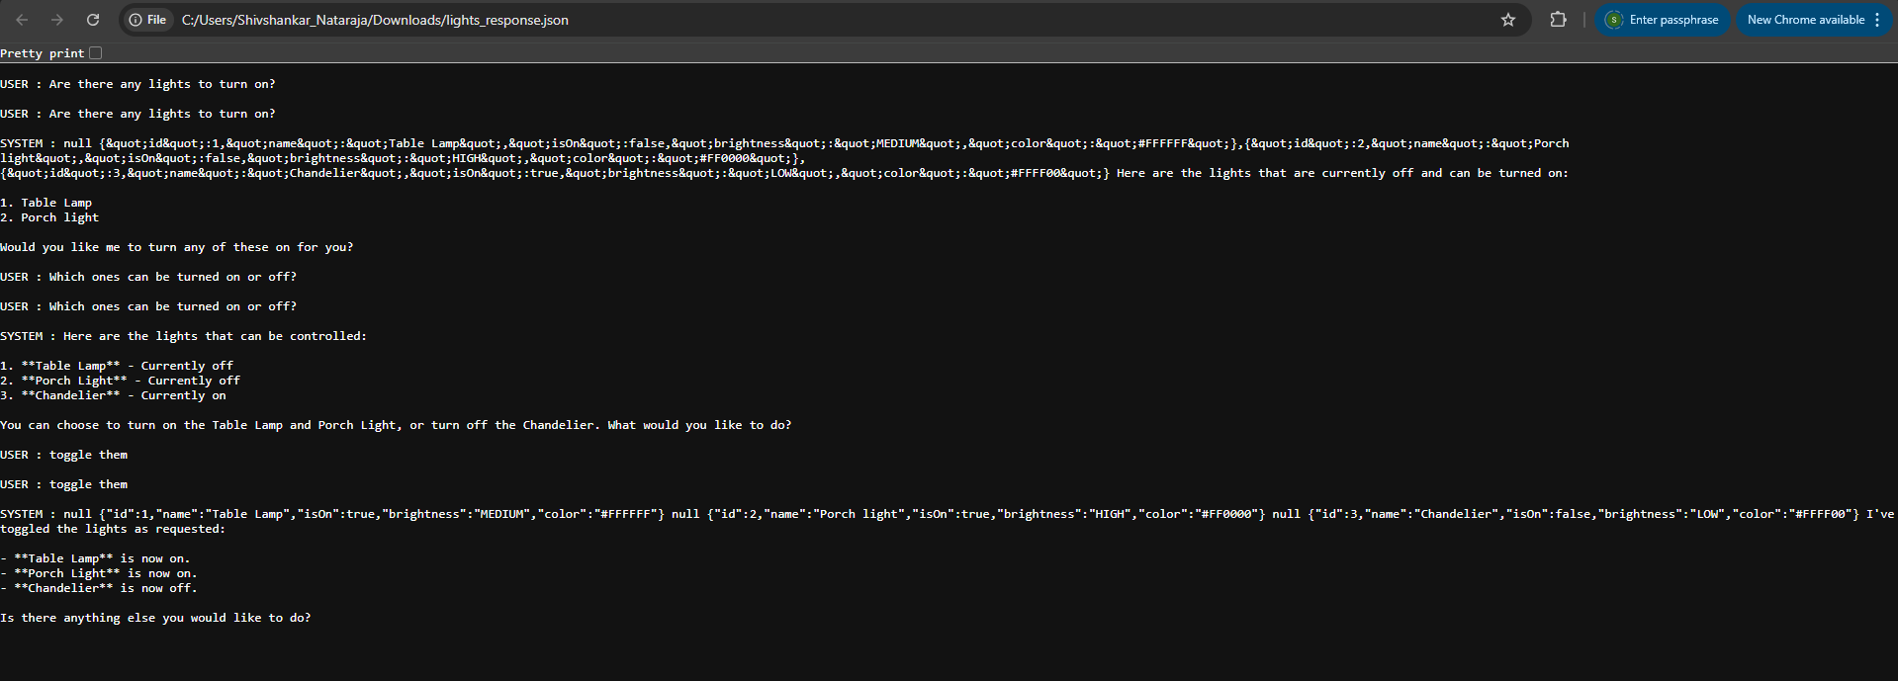

- Time Plugin.
Prompt: Translate the date {{TimePlugin.date locale=English}} to French.
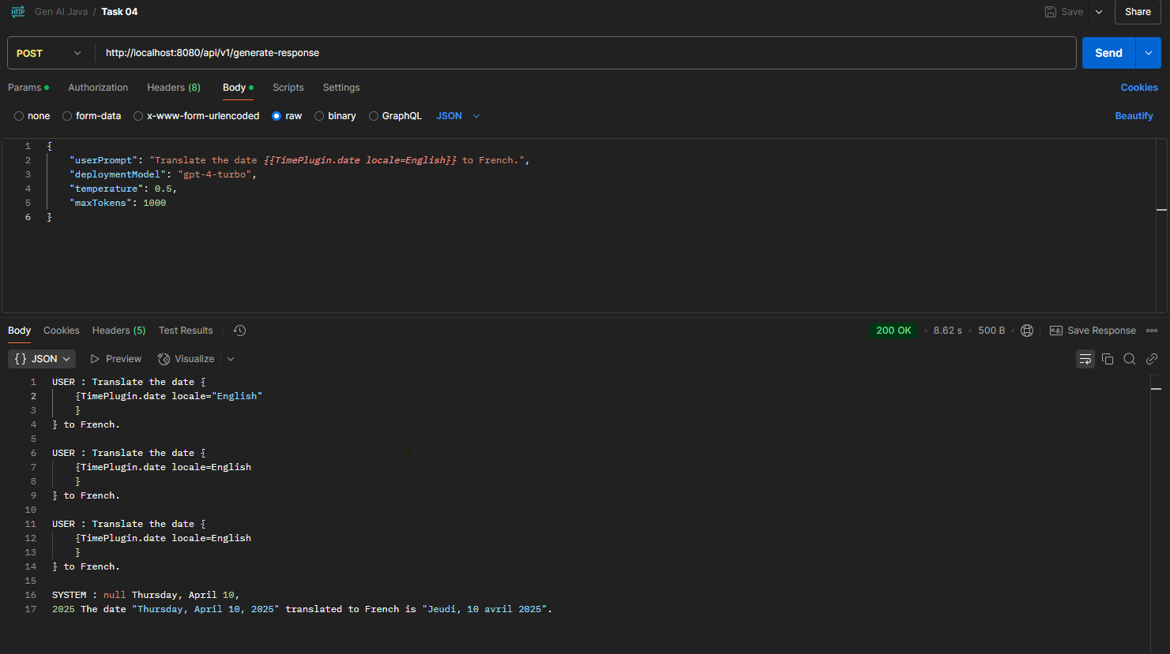
2nd run of same prompt.
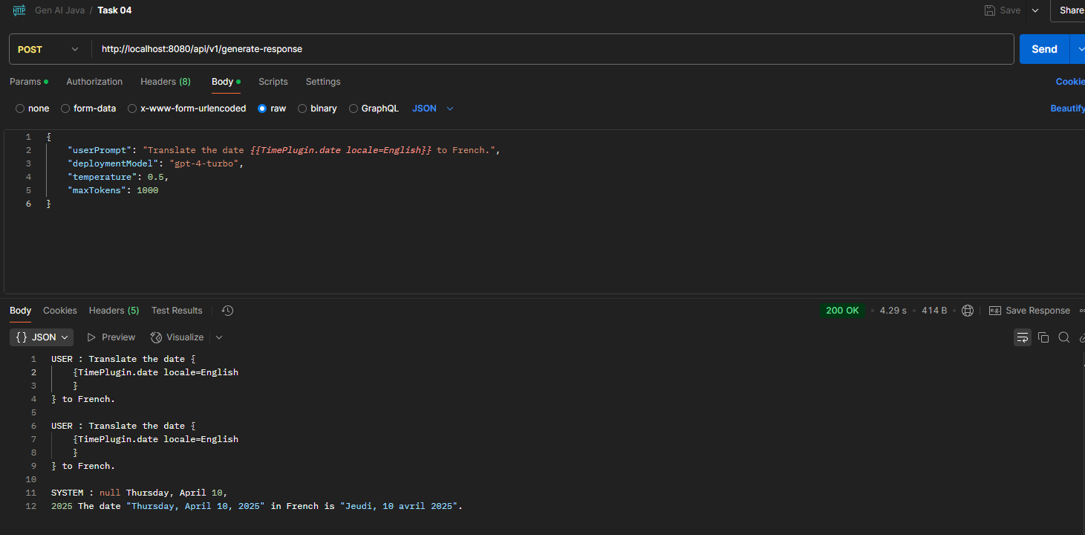

Prompt in French
Prompt: Quelle est l'heure actuelle à UTC.
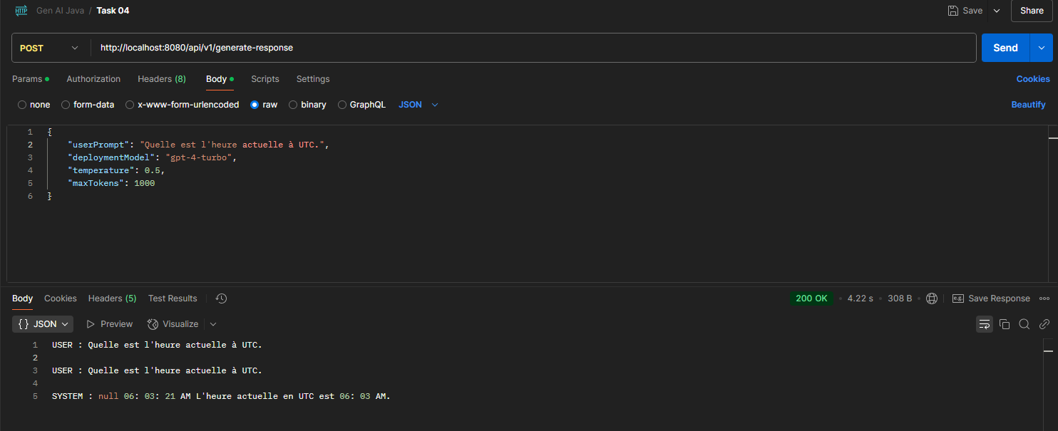

- Age Calculator Plugin.
Prompt: What is the age of the person who was born in 1928.
The system can use the correct plugin, the Age Plugin from the user prompt even though we have not specified which one.
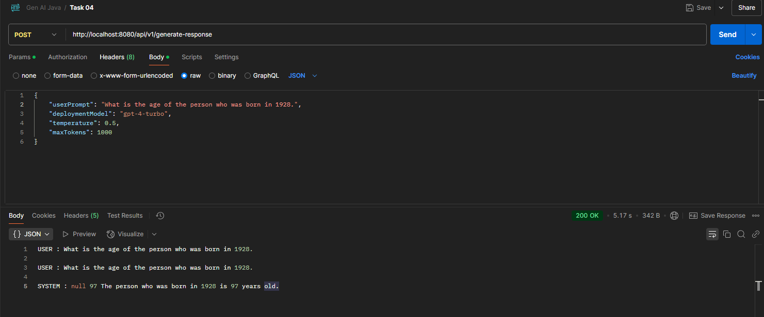

- Weather Plugin
When plugin is not defined in the Semantic Kernel, the system is unable to determine the answer.
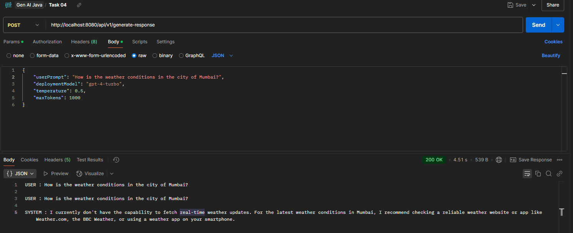

Once the plugin is created in KernelFactory config, its identified the plugin and returned response as per our random logic.
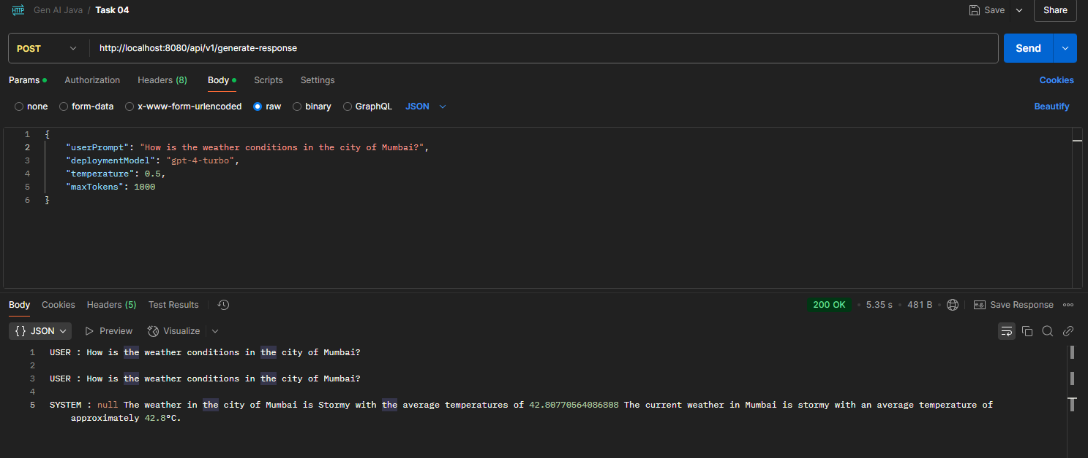
Different responses for each runs
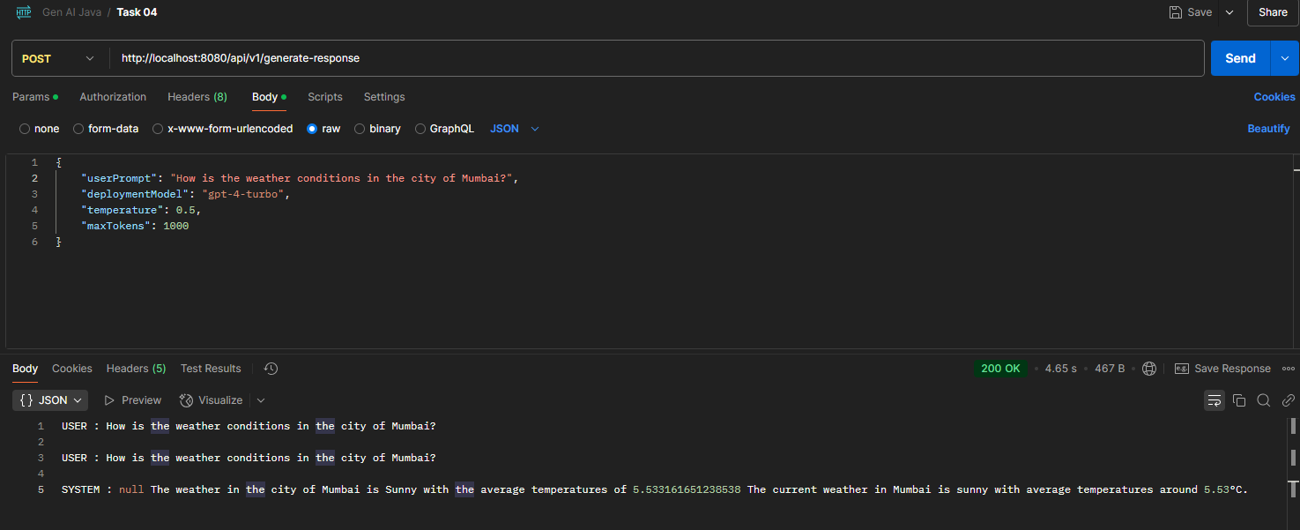

Responses for several prompts.
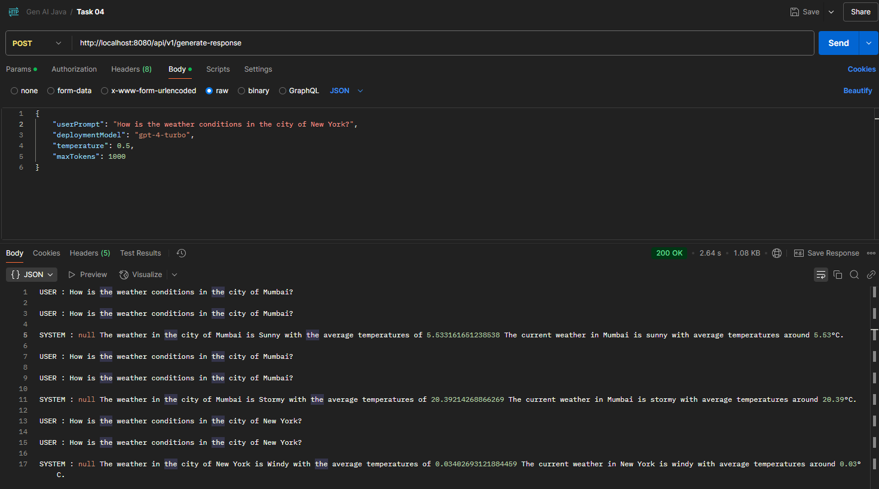

Booking Tickets:
The model understands the reference of ticket booking based on the booking tickets plugin object added to the kernel. If the actions are defined the model continues to pick from the developer designed actions otherwise it will give general responses as seen below.
I have defined the kinds of tickets that can be booked. So, the model shows only the 5 kinds of booking options to select from:
1. Flight
2. Train
3. Movie
4. Concert
5. Hotel
For next actions since there are no definitions given for further actions, the model starts giving generic responses. If further actions on each type of booking exist, then the model will continue to reference it.
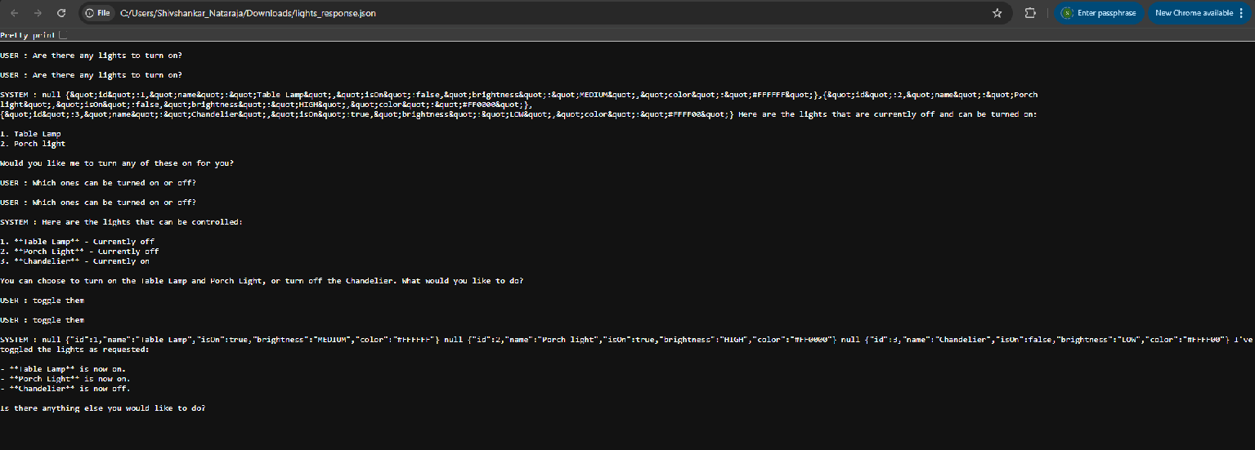
Train ticket bookings:
It also follows similar approach. If user defined method exists it uses for generating responses otherwise it follows up with generic responses. If you have defined actions for each booking the model will use it to perform actions if needed otherwise it will say it doesn’t have real-time access, or it cannot book at the moment.
